Anthony L. Jenkins, Ph.D.
President

CSU AT A GLANCE

2,101 Enrolled (Fall 2023)
185 Transfer Students

Student Body
Founded in 1900, Coppin State University, (CSU) is a comprehensive Historically Black Institution (HBI) originally founded for teacher education. Named in honor of Fanny Jackson Coppin, an outstanding African American educator, Coppin has reaffirmed its dedication to excellence in teaching and student success.
Graduate Undergraduate
Full- time
Part-time Male Female
Living on campus
Average SAT
291 (14%)

1,810 (86%)
1,493 (71%)
608 (29%)
504 (24%)
1,597 (76%)
559
1003 (Math & EBRW)

Academic Programs
34 Bachelor’s
14 Master’s
15 Certificates
Median Student Age 22 Mean Student Age 27
1 Doctorate
64 Academic Programs

Student/Faculty Ratio 10:1
Fall 22 Pell Recipients UGRD 908 (55%), *FTFT 68.13%  Fall 22UGRD Aid Recipients 1,663 (83%) - (80% merit/need based)  Fall 22– 61% 1st Generation (undergrads who received financial aid) | Success Rates  Retention (1st to 2nd year) Graduation (within 6th year) | 74%  25%

Degrees/Certificates Awarded (FY 23)
**408
**includes 9 multiple awards as of 12/12/2023
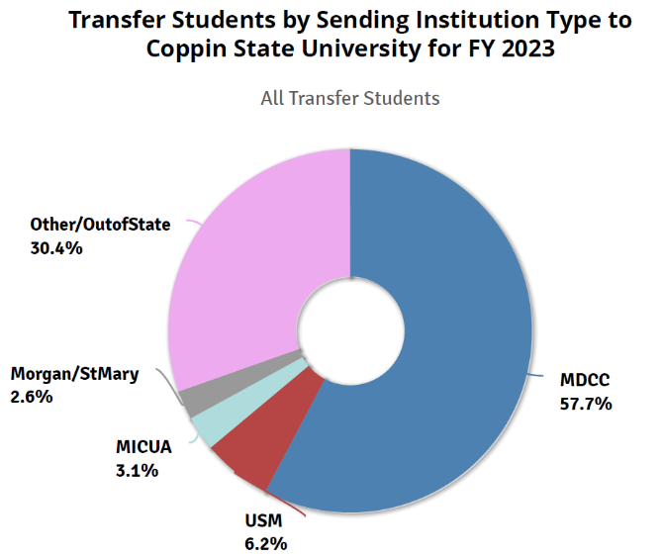

Pass Rates
PRAXIS II 100%
NCLEX 44.44%

Athletics
Mid-Eastern Athletic Conference (MEAC) National Collegiate Athletic Assoc. (NCAA) Division I - baseball, basketball, track, bowling, tennis, volleyball, softball, eSports

Coppin State University is a proud member of the University System of Maryland.

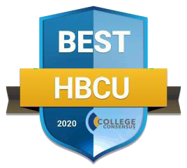
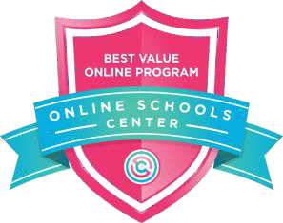
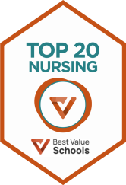

- College Consensus ranked Coppin State University the #4 Historically Black Colleges and Universities in America and #17 for “Best Value in the Nation”
- Coppin has been ranked by the Online School Center as the #5 “Best Value Online Program” for Business Management
- Coppin is also ranked #12 in the top “50 Best Value Colleges for a Nursing Degree” by Best Value Schools

Accreditation
Coppin State University is nationally accredited by the Middle States Commission on Higher Education and is a Carnegie Master's Comprehensive (MA-I) Institution. The University’s programs reflect excellence in discipline- specific accreditations from the following agencies:
- Council for the Accreditation of Educator Preparation (CAEP);
- Commission on Nursing Education (CCNE);
- Council for the Accreditation of Counseling and Related Educational Programs (CACREP);
- Council on Social Work Education (CSWE);
- Commission on Accreditation of Health Informatics and Information Management Education (CAHIIM); and
- Accreditation Council for Business Schools and Programs (ACBSP).

